http://screencast.com/t/JbK4brvL4YpC
Yogendra, this is a video from Craig showing you what we’re looking for on all of the editors.

SynapseIndia-: As per the system integrated in the website, same can not be managed in this way. We need to manage the emails at scripts level as it is running currently.

1: Mail Type: Welcome/30 day free trial
Mail Subject: Thank You for Registering with Personal Training Partners

OK

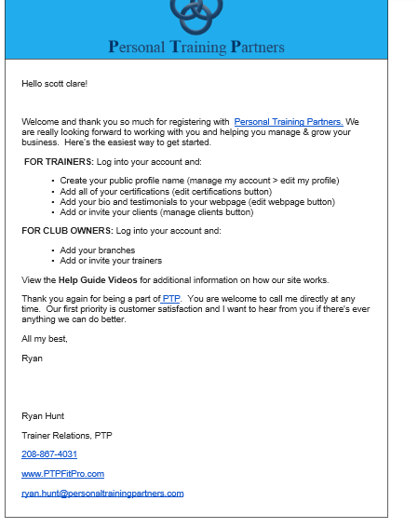
2: Mail Type: Welcome/Registration
Mail Subject: Thank You for Registering with Personal Training Partners

OK

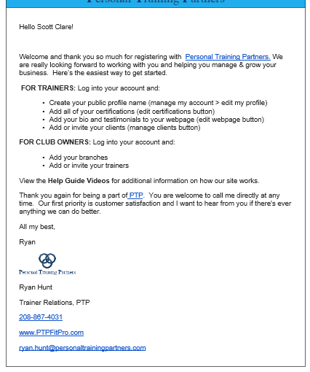

3: Mail Type: Free Nutritional Guide
Mail Subject: Your Free Nutritional Guide from Personal Training Partners

Ok

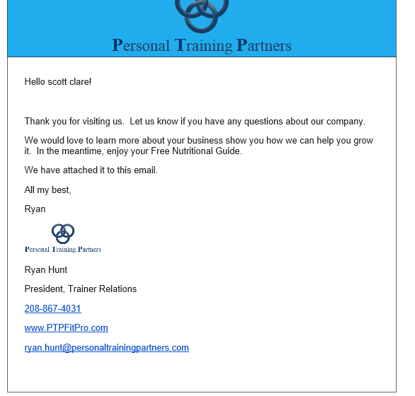

4: Mail Type: Welcome Client/Invite from Trainer
Mail Subject: Welcome
Trainer’s Logo
Hello (client)!
I’m inviting you to use my training software to help us reach your fitness goals.
Please find the link and your log in credentials below. Once you’re logged in click on “edit profile” to change your password. Then just fill in the empty fields.
Website URL: (trainer’s webpage URL)
Username: (clients email
Password: (auto generated password)

I’m excited to work with you! In the meantime, let me know if you need anything.

Thanks,

(trainer name)
(trainer’s phone number)
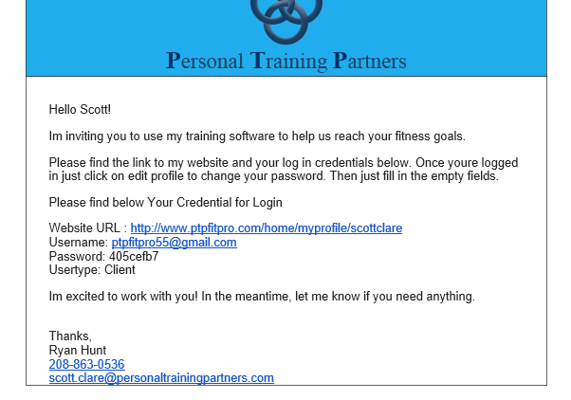
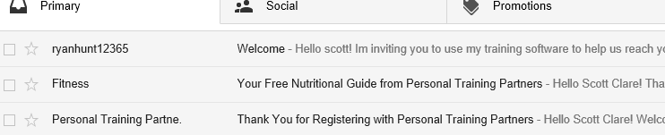
 | 9:16 AM (5 minutes ago)
  Ryan Hunt <scott.clare@personaltrainingpartners.com>
Not correct

This is the correct way… we want all emails from trainers to their clients. Thank you
5: Mail Type: Welcome Client/Add Trainer
Mail Subject: Welcome
Trainer’s Logo
Hello (client)!
I’m inviting you to use my training software to help us reach your fitness goals.
Please find the link to my website and your log in credentials below. Once you’re logged in just click on “edit profile” to change your password. Then just fill in the empty fields.
Website URL: (trainer’s webpage URL) .
Username: (clients email)
Password: (auto generated password)
I’m excited to work with you! In the meantime, let me know if you need anything.
Thanks,
(trainer name)
(trainer’s phone number)
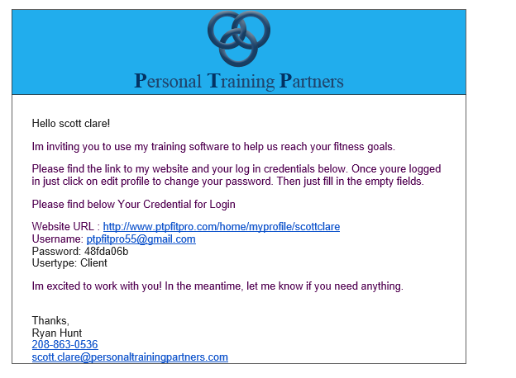
 |  | 8:20 AM (4 minutes ago)
 | 9:16 AM (5 minutes ago)
  Ryan Hunt <scott.clare@personaltrainingpartners.com>
This is the correct way… we want all emails from trainers to their clients. Thank you

6: Mail Type: Client Purchases
Mail Subject: Thank you for Purchasing Training Sessions

Trainer’s Logo
Hello (client),
Thank you for purchasing (session number, session type) sessions from me. I’m looking forward to helping you reach your fitness goals so please feel free to contact me with any questions or concerns regarding your training.
Thanks again,
(trainer’s name)
(trainer’s number)
Trainers email
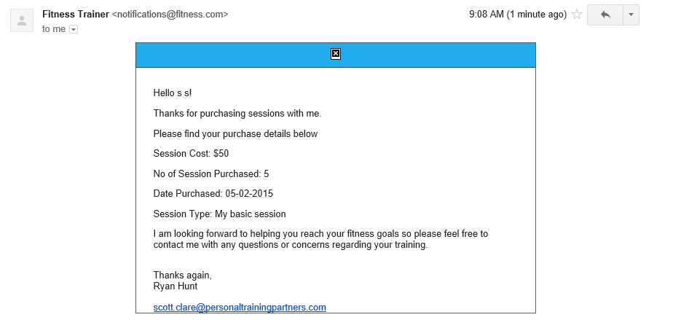
Need trainers phone number to populate at bottom (above his email)

Need trainers logo to show up…this is the same trainer account as 1# - #5 (above)…the logo shows up there why not on # 6 and 7 (basically all the rest below)

Email -: craigaaland@gmail.com
Password-: password
SynapseIndia-: Please check now, also please check with different trainer id as from the ID you are using I think trainer logo is not uploaded. Resolved.

7: Mail Type: Client Session Reminder
Mail Subject: Session Reminder
(Trainer’s Logo)
Hello (client’s name),
Just a reminder that we have a workout scheduled for (date and time of session). See you then!
Thank you,
(Trainer Name)
(Trainer Phone)

[SynapseIndia]-: We are working on this via cron job.

8: Mail Type: Client Session Notification
Mail Subject: Session Status
(Trainier’s Logo)

Hello (Client Name),
Your session on (date) has been (completed, cancelled no charge, cancelled charged, comped). As always, it’s a pleasure to help you reach your fitness goals. Feel free to contact me anytime with questions regarding your training.
Thank You,
(trainer name)
(trainer phone)
 | 9:16 AM (5 minutes ago)
  Ryan Hunt <scott.clare@personaltrainingpartners.com>
This is the correct way… we want all emails from trainers to their clients. Thank you
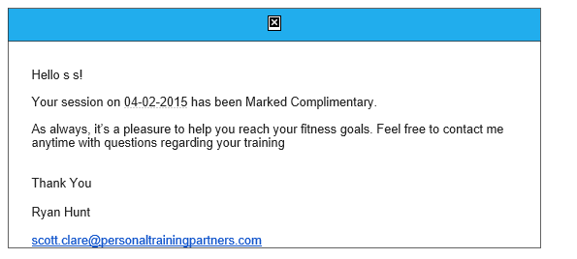
Need trainers logo to show up…this is the same trainer account as 1# - #5 (above)…the logo shows up there why not on # 6 and 7 (basically all the rest below) The logo is uploaded

Need the trainers phone number to be fetched and placed above trainers email

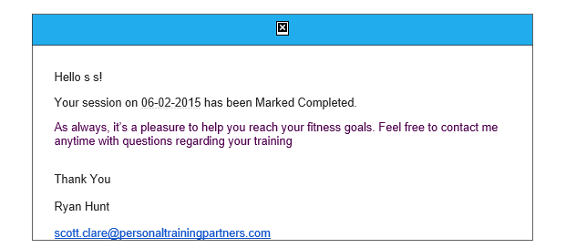
Need the trainers phone number to be fetched and placed above trainers email

Need trainers logo to show up…this is the same trainer account as 1# - #5 (above)…the logo shows up there why not on # 6 and 7 (basically all the rest below) The logo is uploaded

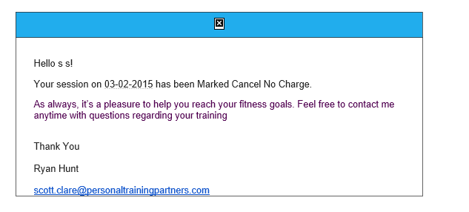
Need trainers logo to show up…this is the same trainer account as 1# - #5 (above)…the logo shows up there why not on # 6 and 7 (basically all the rest below) The logo is uploaded

Need the trainers phone number to be fetched and placed above trainers email

SynapseIndia-: Please check now, also please check with different trainer id as from the ID you are using I think trainer logo is not uploaded. Resolved.
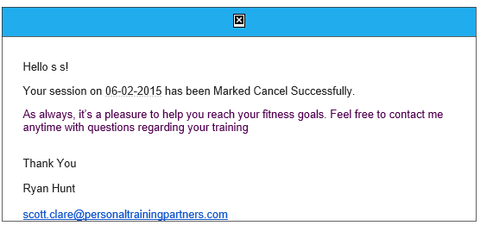
Need it to read: Marked Cancelled Charged

Need the trainers phone number to be fetched and placed above trainers email Need trainers email

Need trainers logo to show up…this is the same trainer account as 1# - #5 (above)…the logo shows up there why not on # 6 and 7 (basically all the rest below) The logo is uploaded

8: This is an email that was generated from a trainer to his client using the trainer’s communication center to send the email.
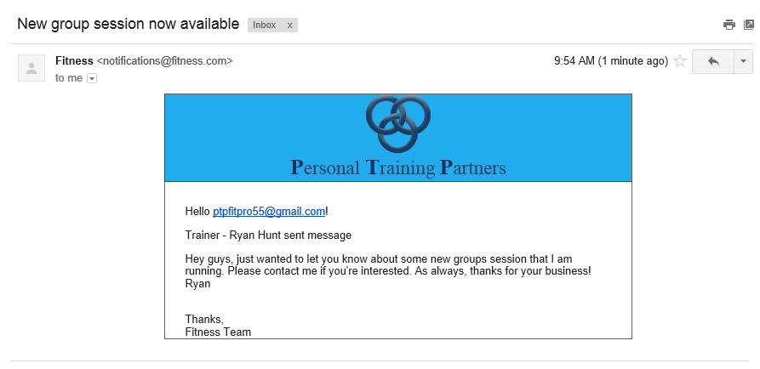
 | 9:16 AM (5 minutes ago)
  Ryan Hunt <scott.clare@personaltrainingpartners.com>
This is the correct way… we want all emails from trainers to their clients. Thank you

Should say Hello (trainer’s name) not his email

Need “trainer – ryan hunt sent message to be removed

Please remove “thanks, fitness team” …… and replace with trainer’s name, phone, and email

9: This is an email sent from a client to his trainer in the client communication center

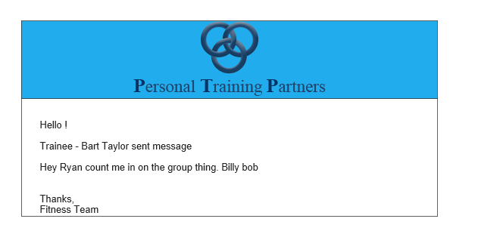
Should read Hello (trainer’s name)

Should say; client – bart taylor sent you a message

Remove: thanks, fitness team

_________________________________________________________

